Dated 29.03.2024

Elastic Beanstalk

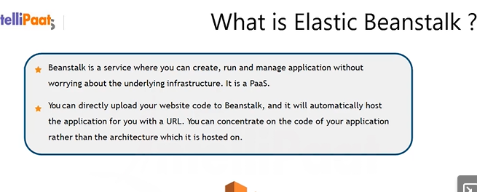

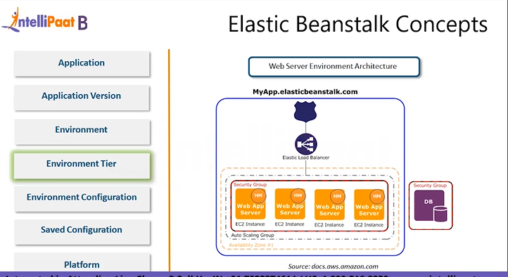

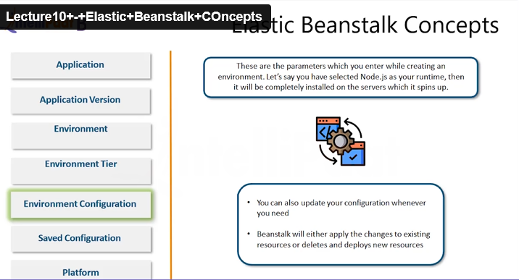

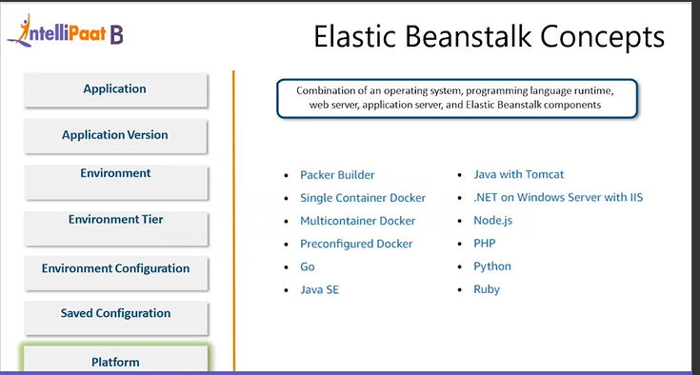

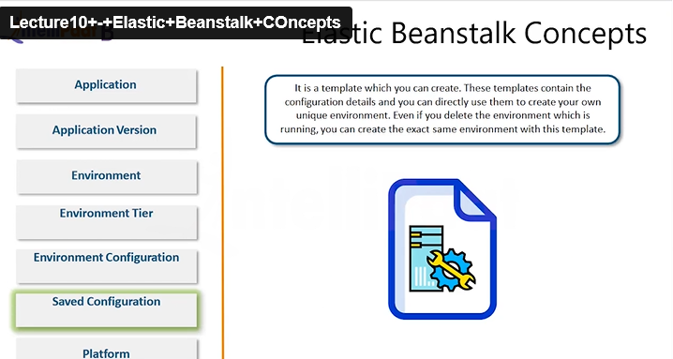

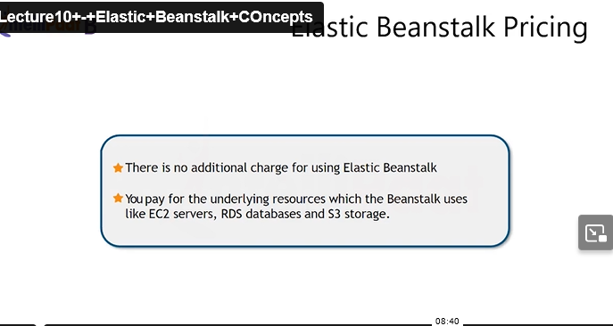

HOW TO CREATE ELASTIC BEANSTALK

Click on create application

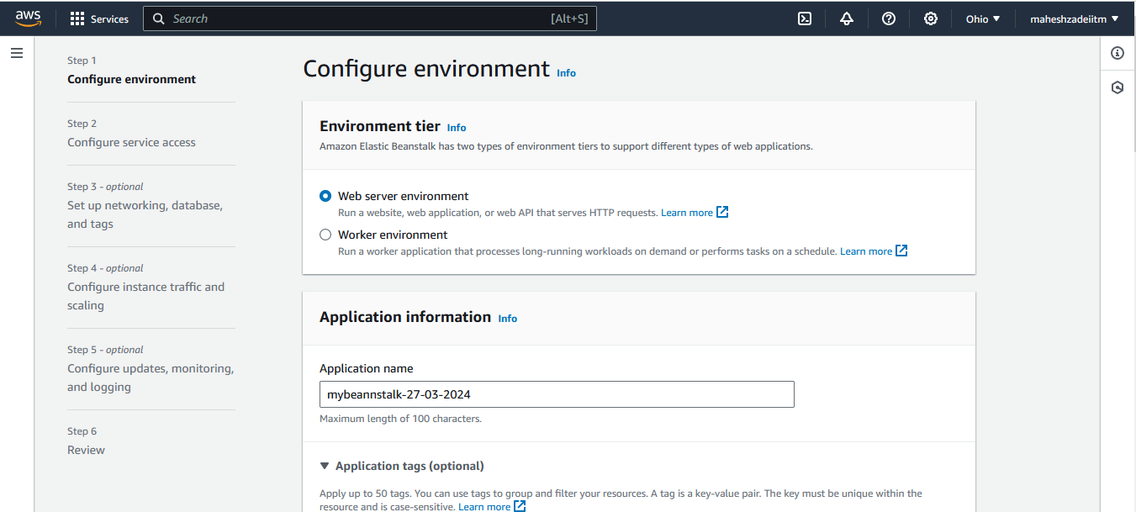

Pu a tag if you are working big company in multiple applications are running , here we don’t require the tag

Environment information already created

Domain name leave blank

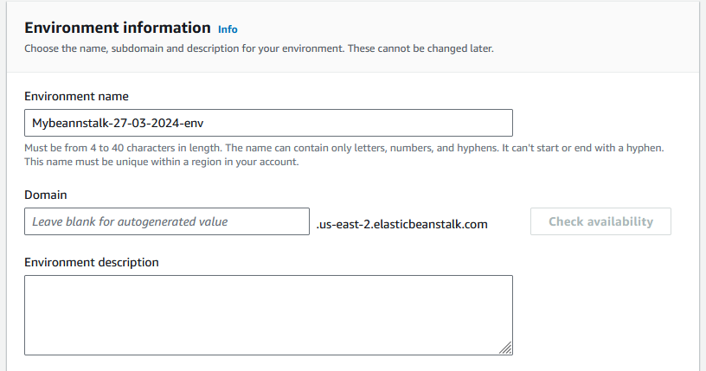

Next option is Managed Platform

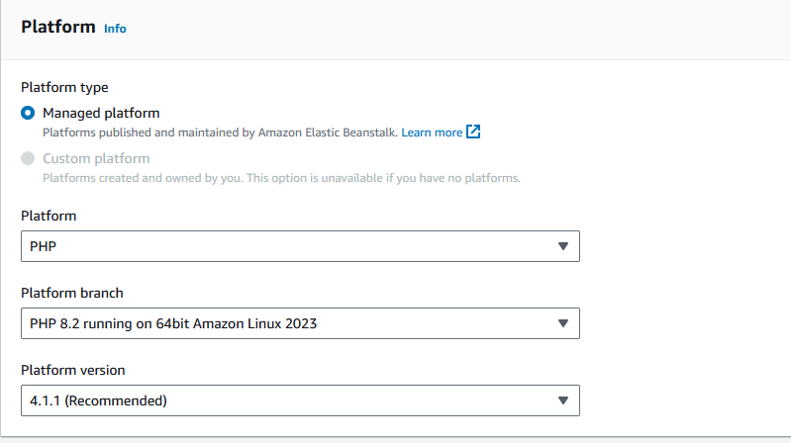

Application Code

U can uload your code if available amnually

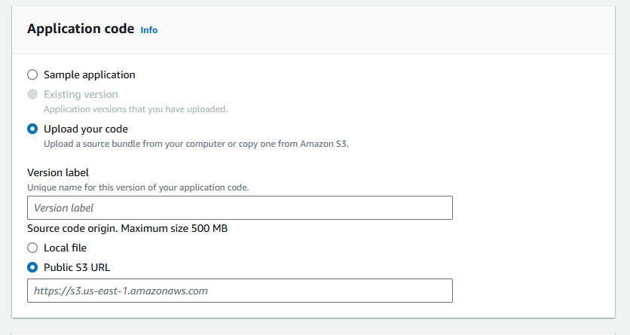

We can upload the file from local as well as from s3 bucket

For test we will go with Sample application

Click on next

Configure Services access

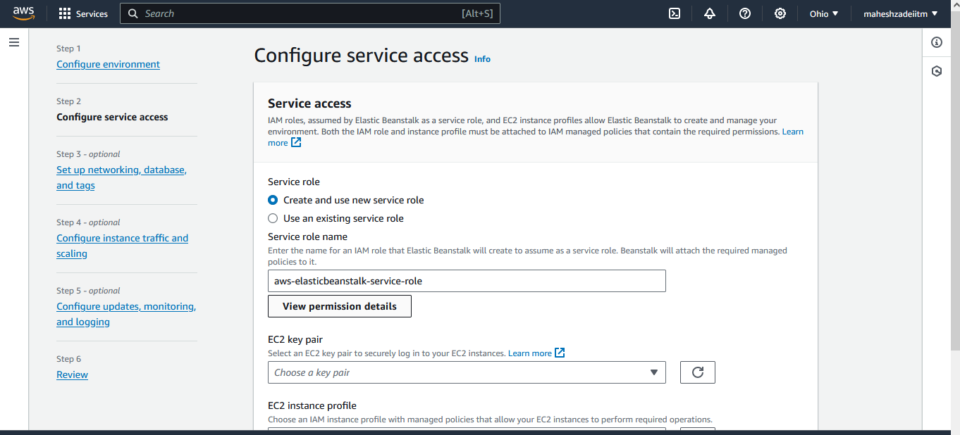

Click on Create and use new service role

View permissions

This is a JSON Policy

What is the Full form of JSON? The full form of JSON is **JavaScript Object Notation**

**This policy and permission created by AWS   
Lets Click on Next**

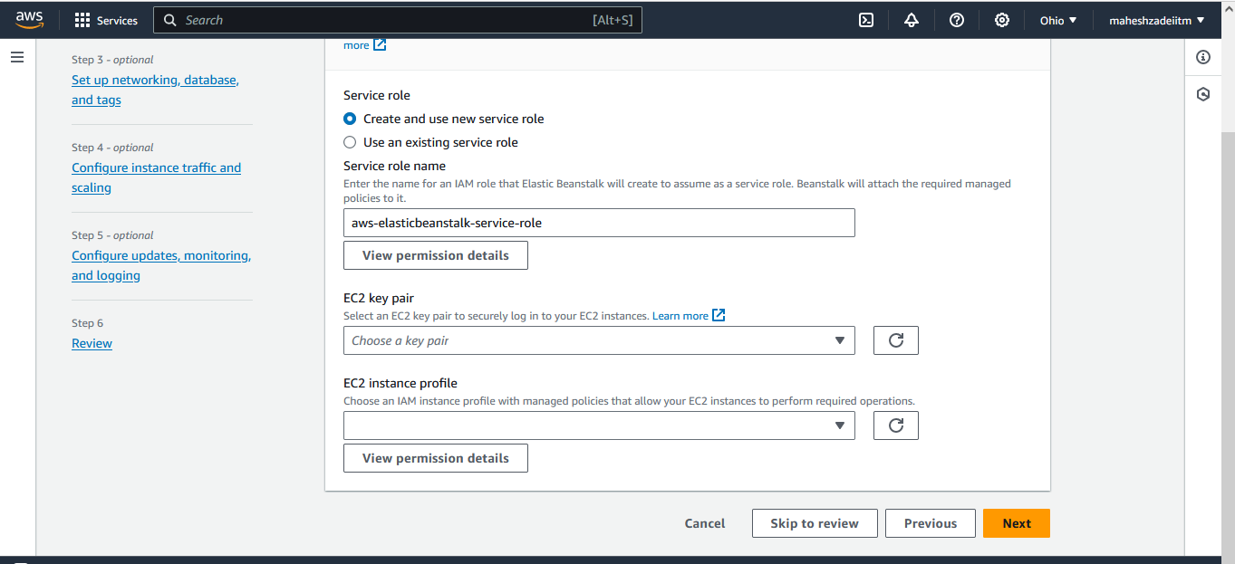

Custom VPC is Preferred , but for Demo we will use the default VPC

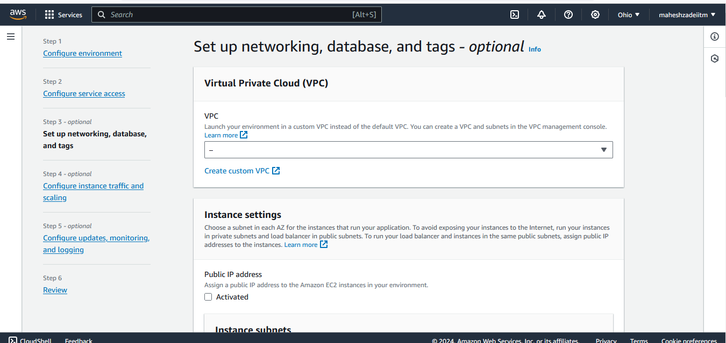

Use Default VPC and Activate Public IP

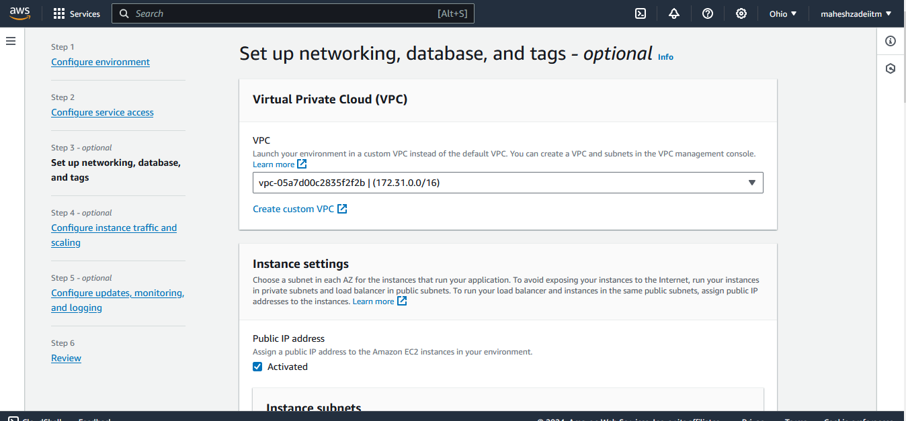

Click on all Availability Zone

No need to choose database ad this is a demo

Use general Purpose Volume

Check Security Group Default

Rest keep the setting remain same

Choose the root Volume 10 GB instead of 8 GB as its required 10 GB Minimum

Cliick on Next

Click Saturday Or Sunday for the updates

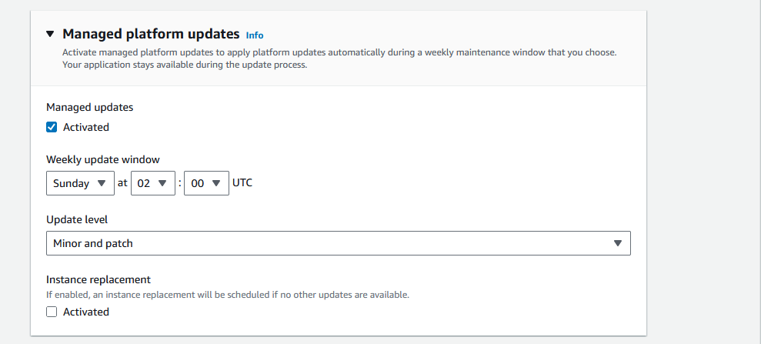

Rest keep the all the settings defaults

And click on next

Error shows

So choose the enhanced health reporting above.

REVIEW the setting and click on Submit

At the backend EC2 Instance is creating

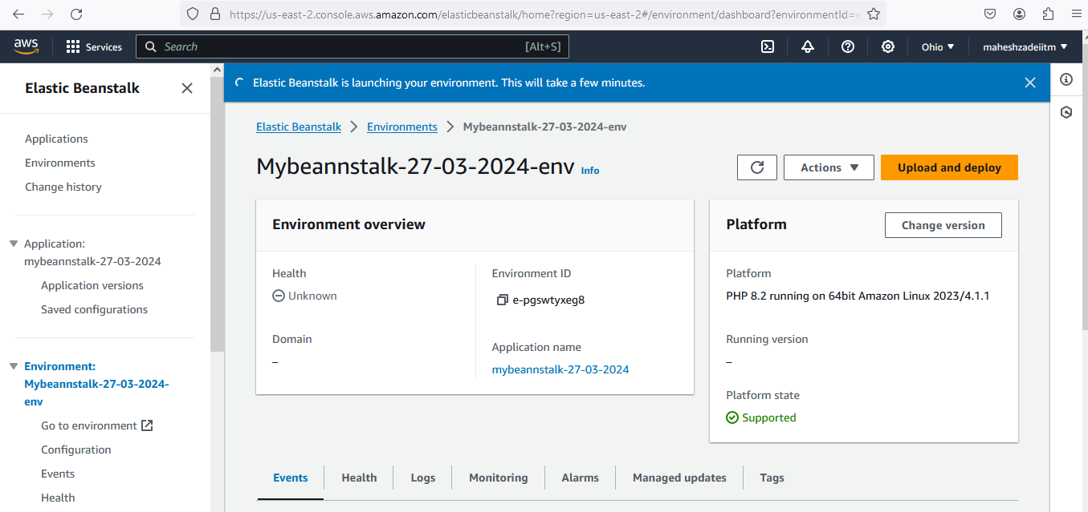

Still its taking Time

Got the error unbale to Launch Elastic Beanstalk

Can you Pls help me to resolve this query

Thanks